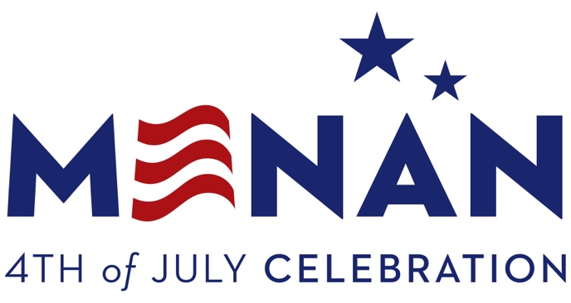
T : (208) 754-8876
F : (208) 754-0919

PO Box 127
Menan, ID 83434
menan@ida.net

BOOTH / VENDOR REGISTRATION FORM
Be it known that for the enclosed payment of $__________, the full receipt of which is acknowledged, the undersigned ____________________________ (Vendor) hereby rents booth space from the City of Menan, as follows :
Organization / Business Name | Mailing Address
Phone No. | Email
Using Generator (Yes or No) | Size of Trailer
Require Menan to Supply Electricity | Preferred Booth Number(s)
Number of Spaces Required (10’ x 10’ each) | Preferred Booth Number(s) or Special Requests
Products, Food, Items For Sale

By signing, I verify that I have read the accompanying Terms and Conditions.

Vendor Signature _____________________________________ Date _____________
*NOTE: Food Vendors, don’t forget to include a copy of your Health Department permit.

MENAN VENDOR REGISTRATION TERMS AND CONDITIONS
By returning the completed Registration Form with payment / permit to the Menan City Clerk, you are agreeing to abide by the following terms and conditions:
- The City of Menan is not responsible for any lost, stolen or damaged property.
- No smoking or alcoholic beverages allowed.
- No sale of fireworks or water toys.
- Booth spaces are 10’ x 10’. If you require more space, you MUST PAY for additional booth space. Please indicated the number of booth spaces you require. If your booth exceeds your reserved space (this includes trailer hitches), you may be refused or relocated, at our discretion.
- Food Booth Fees
  - Standard Booth $25
  - Standard Booth w/ Power $50
  - Food Booth $75
  - Food Booth w/ Power $100
- There are no refunds. If you register, make sure that you will be able to attend.
- Booths must be set up between 8 pm July 3 & 10 am July 4, then removed between 6 & 10 pm of July 4th.
- Designated vendor parking is first come first served along the streets to the east and north of the booth area. No trailers are allowed in the parking areas, including camp trailers.
- You must supply your own equipment (including extension cords if your booth requires electricity). You may supply your own generator, but it must be shielded to prevent exhaust burns, and it must be located inside your designated booth area (out of walkways).
- Health Department Permits - If you are selling food or beverages of any kind, you must obtain a permit from the Health Department, and include a copy with your booth payment. The deadline for food booth vendors is June 17. NO EXCEPTIONS!!! We are required to provide copies of these permits to the Health Department two weeks prior to the event.

