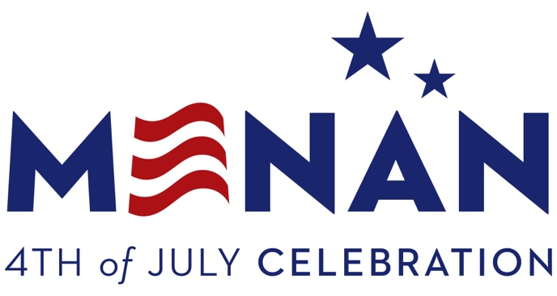
T : (208) 754-8876
F : (208) 754-0919

PO Box 127
Menan, ID 83434
menan@ida.net

PARADE ENTRY FORM
Thank you for your interest in Menan’s 4th of July Parade. We appreciate all those who celebrate American independence in our little town (13,000 – 18,000 every year).
*NOTE: To help with the cost of dumpsters and the after-Parade-pick-up-party (think horses / wrappers), please consider a small contribution. You can include cash or a check made out to : City of Menan – Parade Donation, or speak with a member of the Parade Committee on the 4th.
To help streamline and organize the Parade, please provide the following information :
Organization / Business Name | Mailing Address
Phone No. | Email
Size of Vehicle(s), Float, Entry | Number of Vehicle(s), Entries
Number of Participants | Special Requests
What (if anything) are you throwing / giving away during Parade

Signature ___________________________________________ Date _____________

